Hanson Masonry & Concrete, LLC
2010 Poster Contest

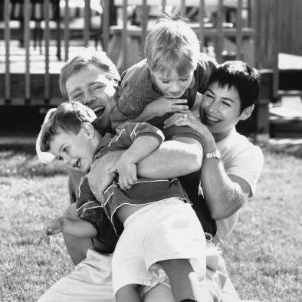
For the first time ever, we will be holding a poster contest to involve family members and friends in worker safety. Employee family members in grades Pre-K – 12th are invited to submit their creative, original artwork centering on the contest’s theme of, “Work Safely—Your Family Needs You!” The winning entries will be displayed in the company newsletter, our office and jobsites, at the annual Christmas Party; and will also receive a prize!

- Contest is open to all students in grades Pre-K through 12th. Sons, daughters, nieces, nephews, and friends of the family are invited to join!
- The theme is “Work Safely—Your Family Needs You!”
- The student’s name, address, phone number, and grade level should be on the back of the sheet.
- The poster can be colored and/or decorated any way the student would like.
- Entries are due by January 31, 2011.
- All entries can be mailed or emailed to:

Hanson Masonry & Concrete, LLC
ATTN: Kristie Kohn
P.O. Box 272
Owen, WI 54460

Email: kkohn@hansonmc.com

- The student’s artwork should be relevant to our theme: “Work Safely—Your Family Needs You!”
- If you have any questions please contact Kristie Kohn: kkohn@hansonmc.com.

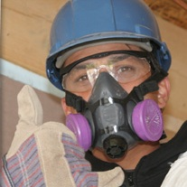
If you need some ideas, check out some of these websites:
www.osha.gov
www.elcosh.org
www.cdc.gov
www.wiscosh.org
www.nsc.org

Some important safety concerns for those working in the construction industry are:

- Wearing Personal Protective Equipment (like safety glasses and hard hats)

- Fall protection; ladder and scaffold safety
- Back injuries and safe lifting practices
- Power saw and hand tool safety
- Heavy equipment and forklift operation
- Electrical safety
